Assignment: **Troubleshooting and Helpdesk**

Section 1: Multiple Choice

1. What is the first step in the troubleshooting process?

Ans: B] Identifying the problem

1. Which of the following tools is commonly used to diagnose hardware  
   issues by testing electrical connections?

Ans: C] Multimeter

1. Which of the following best describes the purpose of a VPN (Virtual  
   Private Network)?

Ans: A] Encrypting network traffic to prevent eavesdropping

1. Which Windows utility can be used to view system logs, monitor  
   performance, and diagnose hardware and software issues?

Ans: C] Event Viewer

**Section 2: True or False**

1. True or False: Safe Mode is a diagnostic mode in Windows that loads  
   only essential system services and drivers, allowing users to  
   troubleshoot and fix problems with the operating system.

Ans: True

1. True or False: A system restore point is a snapshot of the computer's  
   system files, registry, and configuration settings at a specific point in  
   time, which can be used to revert the system to a previous state if  
   problems occur.

Ans: True

1. True or False: Ping is a command-line utility used to test network  
   connectivity by sending ICMP echo requests to a target device and  
   waiting for ICMP echo replies.

Ans: True

**Section 3: Short Answer**

8] Describe the steps involved in troubleshooting a computer that fails to  
boot into the operating system

Ans:

* Power On: Ensure the computer is receiving power and the power light is on.
* Boot Order: Check if the boot order is set to boot from the correct device.
* Bootable Media: Check if the bootable media is properly inserted and recognized by the computer.
* BIOS: Check if the system BIOS is set to boot from the correct device.
* Blank Screen: If the computer is booting up but the screen is blank or shows error messages, try pressing the F2, F8, F12, or Delete keys to access the BIOS setup menu.
* Clean Boot: Perform a clean boot by pressing Ctrl + Alt + Del keys to access the Task Manager and select the "Startup" tab.
* Hard Drive: If the hard drive is faulty, replace it with a new one.
* Motherboard or CPU: If the computer is still not booting, it may be necessary to replace the motherboard or the CPU.
* RAM or Power Supply: If the computer is still not booting, it may be necessary to replace the RAM or the power supply.
* Video Card or Monitor: If the computer is still not booting, it may be necessary to replace the video card or the monitor.
* Network Card or Cable: If the computer is still not booting, it may be necessary to replace the network card or the network cable.
* Hard Drive: If the computer is still not booting, it may be necessary to replace the hard drive.

**Section 4: Practical Application**

9] Demonstrate how to troubleshoot network connectivity issues on a  
Windows computer using the ipconfig command

Ans:

1.Open the Start menu and type "cmd" in the search box.

2. Right-click on the "Command Prompt" app and select "Run as administrator".

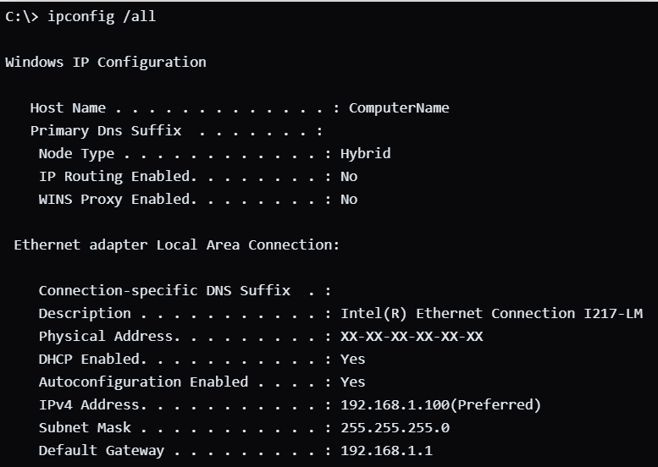

* Open the Command Prompt by clicking the Start button, typing "cmd" in the search box, and pressing Enter.
* Type ipconfig /all and press Enter. This command will display all the network configuration information for all network adapters on the computer.
* Look for any error messages or issues in the output. If there are any, they may indicate the cause of the connectivity issue.
* If the output shows that the computer is connected to a network, but cannot access the internet, try the following:
* Check the network settings in the Control Panel. Open the Control Panel, navigate to "Network and Internet" > "Network and Sharing Center" > "Change Adapter Settings".
* Verify that the network adapter is enabled and has the correct settings (e.g., IP address, subnet mask, default gateway, DNS server).
* If the settings are correct, try manually setting the DNS server to a known working server (e.g., Google's DNS server: 8.8.8.8).
* If the output shows that the computer is not connected to a network, try the following:
* Check the physical connections between the computer and the router or modem. Make sure the cables are properly plugged in and not damaged.
* Use a network tester or a cable tester to check for any physical issues.
* If the issue persists, reset the network adapter by right-clicking on the network icon in the taskbar, selecting "Open Network and Sharing Center", right-clicking on the network adapter, and selecting "Disable" and then "Enable" the adapter.
* If the issue persists, try restarting the computer. If the problem is resolved after a restart, it may be a temporary issue that can be resolved by restarting the computer.
* If the issue persists and the computer is still not connected to the network, contact the network administrator or the ISP for assistance. Provide details about the problem, including the computer's make and model, the router or modem model, and any error messages or connection issues.

**Section 5: Essay**

10] Discuss the importance of effective communication skills in a helpdesk  
or technical support role.

Ans:

Effective communication skills are crucial for technical support and helpdesk roles. These skills enable technicians to convey information clearly, receive feedback accurately, and resolve issues efficiently. Key aspects include active listening to understand customer concerns fully, explaining technical details in simple terms, and maintaining a patient and empathetic demeanour. For instance, when a customer struggles with a software installation, a technician who listens attentively, provides clear step-by-step instructions, and reassures the customer can significantly improve the support experience. By practicing these skills, technicians can provide excellent customer service, resolve issues promptly, and build positive relationships with customers.

Continual development of communication skills is essential for success in technical support roles. Technicians should strive to enhance their abilities daily and adapt to different customer situations. This ongoing improvement helps maintain relevance in the rapidly evolving technical support landscape, ensuring that technicians can offer the best possible assistance. For example, learning to adjust communication styles based on the customer's technical proficiency can lead to more effective problem-solving and higher customer satisfaction. Additionally, clear and accurate communication aids in documenting issues, collaborating with team members, and sharing knowledge within the organization. By investing in the development of these skills, technicians can contribute to a more efficient and supportive helpdesk environment, ultimately leading to better overall service and customer loyalty.